* **Factor Analysis**

|  |  |  |
| --- | --- | --- |
| **KMO and Bartlett's Test** | | |
| Kaiser-Meyer-Olkin Measure of Sampling Adequacy. | | .674 |
| Bartlett's Test of Sphericity | Approx. Chi-Square | 1363.529 |
| df | 351 |
| Sig. | .000 |

Interpretation

* KMO TEST
* According to data, Kaiser-Meyer-Olkin measure of sample adequacy is 0.674 which is acceptable.
* Data is suitable for factor analysis.
* BARTLETT’S TEST
* Test is for correlation matrix

To test H0: correlation matrix is identity matrix

H1: correlation matrix is not identity matrix

In above table Bartlett’s test of significance is 0.00, which is less than 0.05 therefore, we reject H0. We conclude that correlation matrix is not identity matrix

* Correlation matrix (Table not provided due to being too large)
* In correlation matrix, value is greater than or equal to 0.8 that means that two variables are highly correlated.
* According to data, none of the variable have greater than or equal to 0.8
* So, no variable is highly correlated with each other.
* Communalities Table

|  |  |  |
| --- | --- | --- |
| **Communalities** | | |
|  | Initial | Extraction |
| VAR00001 | 1.000 | .561 |
| VAR00002 | 1.000 | .568 |
| VAR00003 | 1.000 | .545 |
| VAR00004 | 1.000 | .616 |
| VAR00005 | 1.000 | .575 |
| VAR00006 | 1.000 | .508 |
| VAR00009 | 1.000 | .579 |
| VAR00010 | 1.000 | .546 |
| VAR00011 | 1.000 | .629 |
| VAR00012 | 1.000 | .573 |
| VAR00013 | 1.000 | .633 |
| VAR00014 | 1.000 | .754 |
| VAR00015 | 1.000 | .657 |
| VAR00016 | 1.000 | .612 |
| VAR00018 | 1.000 | .600 |
| VAR00019 | 1.000 | .553 |
| VAR00020 | 1.000 | .683 |
| VAR00021 | 1.000 | .588 |
| VAR00022 | 1.000 | .503 |
| VAR00023 | 1.000 | .646 |
| VAR00024 | 1.000 | .660 |
| VAR00026 | 1.000 | .531 |
| VAR00027 | 1.000 | .604 |
| VAR00028 | 1.000 | .588 |
| VAR00029 | 1.000 | .667 |
| VAR00030 | 1.000 | .606 |
| VAR00031 | 1.000 | .587 |
| Extraction Method: Principal Component Analysis. | | |

Interpretation

* Communalities indicate the common variance shared by

factors with given variable.

* A communality is the extent to which an item correlate

With all other item.

* + - Proportion of each variable that can be explained by the

Factors.

Initial communalities are generally taken as 1.

|  |  |  |  |  |  |  |  |  |  |  |
| --- | --- | --- | --- | --- | --- | --- | --- | --- | --- | --- |
| **Component Matrixa** | | | | | | | | | | |
|  | Component | | | | | | | | | |
| 1 | 2 | 3 | 4 | 5 | 6 | 7 | 8 | 9 | 10 |
| VAR00009 | .531 |  |  |  | .338 |  |  |  |  |  |
| VAR00018 | .529 |  |  |  |  |  |  |  | .359 |  |
| VAR00021 | .501 |  |  |  |  |  |  |  |  |  |
| VAR00011 | .501 |  |  |  | .415 |  |  |  |  |  |
| VAR00019 | .500 |  |  |  |  |  |  | -.330 |  |  |
| VAR00014 | .464 | .422 | -.302 |  |  |  | -.322 |  |  |  |
| VAR00012 | .400 | -.352 |  |  |  |  |  |  |  |  |
| VAR00030 |  | -.542 |  |  |  | .339 |  |  | -.369 |  |
| VAR00015 | .349 | .506 | -.386 |  |  |  |  |  |  |  |
| VAR00003 | .312 | -.463 |  |  |  |  |  |  |  |  |
| VAR00002 |  | .434 |  |  |  | -.325 | .363 |  |  |  |
| VAR00016 |  | .423 |  | .359 |  |  |  |  |  |  |
| VAR00006 |  | .343 |  |  |  | .324 |  |  |  |  |
| VAR00028 | -.312 | .431 | .447 |  |  |  |  |  |  |  |
| VAR00023 |  |  | .418 |  |  |  |  | .411 |  | .318 |
| VAR00024 | .348 |  | .405 |  |  |  |  |  |  | -.365 |
| VAR00029 |  | -.311 | .402 |  |  |  |  |  |  |  |
| VAR00031 |  |  |  | .510 |  |  |  |  |  |  |
| VAR00026 |  |  | .418 | .435 |  |  |  |  |  |  |
| VAR00022 |  |  | .344 | -.392 |  |  |  |  |  |  |
| VAR00010 | .382 |  |  | .382 |  | -.313 |  |  |  |  |
| VAR00004 | .306 | .383 |  |  | .424 |  |  |  |  |  |
| VAR00001 | .356 |  |  |  | .418 |  |  |  |  |  |
| VAR00027 |  |  |  |  |  | .450 | .404 | -.335 |  |  |
| VAR00005 | .362 |  |  |  | -.358 |  |  |  | -.408 |  |
| VAR00020 |  |  |  |  |  |  |  |  |  | -.561 |
| VAR00013 |  |  |  |  |  |  | .387 | .379 |  | -.408 |
| Extraction Method: Principal Component Analysis. | | | | | | | | | | |
| a. 10 components extracted. | | | | | | | | | | |

**Component Matrix**

**Interpretation:**

Extraction by Principal Component Analysis. We extract 10 components.

|  |  |  |  |  |  |  |
| --- | --- | --- | --- | --- | --- | --- |
| **Total Variance Explained** | | | | | | |
| Component | Initial Eigenvalues | | | Extraction Sums of Squared Loadings | | |
| Total | % of Variance | Cumulative % | Total | % of Variance | Cumulative % |
| 1 | 3.301 | 12.225 | 12.225 | 3.301 | 12.225 | 12.225 |
| 2 | 2.399 | 8.887 | 21.111 | 2.399 | 8.887 | 21.111 |
| 3 | 1.700 | 6.295 | 27.406 | 1.700 | 6.295 | 27.406 |
| 4 | 1.564 | 5.793 | 33.200 | 1.564 | 5.793 | 33.200 |
| 5 | 1.408 | 5.213 | 38.413 | 1.408 | 5.213 | 38.413 |
| 6 | 1.254 | 4.643 | 43.056 | 1.254 | 4.643 | 43.056 |
| 7 | 1.225 | 4.536 | 47.592 | 1.225 | 4.536 | 47.592 |
| 8 | 1.140 | 4.221 | 51.814 | 1.140 | 4.221 | 51.814 |
| 9 | 1.117 | 4.136 | 55.949 | 1.117 | 4.136 | 55.949 |
| 10 | 1.067 | 3.951 | 59.900 | 1.067 | 3.951 | 59.900 |
| 11 | .958 | 3.548 | 63.448 |  |  |  |
| 12 | .915 | 3.388 | 66.836 |  |  |  |
| 13 | .874 | 3.237 | 70.074 |  |  |  |
| 14 | .794 | 2.939 | 73.013 |  |  |  |
| 15 | .771 | 2.857 | 75.870 |  |  |  |
| 16 | .709 | 2.627 | 78.497 |  |  |  |
| 17 | .683 | 2.529 | 81.026 |  |  |  |
| 18 | .670 | 2.481 | 83.507 |  |  |  |
| 19 | .598 | 2.215 | 85.723 |  |  |  |
| 20 | .587 | 2.175 | 87.897 |  |  |  |
| 21 | .541 | 2.002 | 89.900 |  |  |  |
| 22 | .534 | 1.978 | 91.878 |  |  |  |
| 23 | .498 | 1.844 | 93.721 |  |  |  |
| 24 | .470 | 1.742 | 95.463 |  |  |  |
| 25 | .449 | 1.662 | 97.125 |  |  |  |
| 26 | .431 | 1.595 | 98.720 |  |  |  |
| 27 | .346 | 1.280 | 100.000 |  |  |  |
| Extraction Method: Principal Component Analysis. | | | | | | |

We extract 10 components from the data, where these components extract almost 60% of the variation in the data.

Component 1:

According to data self-esteem, positive emotions, Altruism, Achievement striving and Excitement seeking are variables which are correlated to each other are defined in first component.

Component 2:

Also, Gregariousness and Artistic interest are slightly correlated to each other which are defined in second component.

Component 3:

Depression, Modesty, Intellectual Interest, co-operation and self consciousness , these all are related with each other and defined in our third component because variation of these variables are higher than all other components.

***SCREE PLOT***

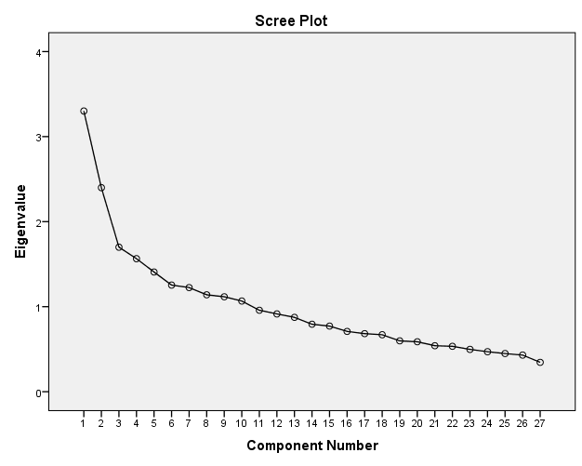

**Interpretation of Scree Plot:**

These results show the unrotated factor loadings for all the factors using the principal component method of extraction.

In above Scree plot, there are 10 components which are explained by 3 factors having greater than 1 eigen value.

The percentage of variability explained by factor 1 is 25.62% by factor 2 is 5.06% and by factor 3 is 20.9%

The Scree plot shows that the first three factors account for most of the total variability in data. The remaining factors account for a very small proportion of the variability.